Post-9/11 Perceptions of Islamic Finance

S Nazim Ali
Director, Islamic Finance Project, Harvard Law School
Harvard University, Cambridge, MA 02138, USA
Email. nazimali@law.harvard.edu Tel +1 617 496 2296 Fax +1 617 496 2373

Abdur Rahman Syed
Doctoral Candidate, Boston University, Boston, MA, USA
Email: asyed@bu.edu Tel. +1 617 880 9220

Abstract: This study investigates perceptions of the Islamic finance industry and impacts on the industry following 9/11 by studying representations in mainstream media, and by surveying Islamic finance industry professionals and Islamic finance media professionals globally for their perceptions and experiences post-9/11. Study of media articles related to Islamic finance post-9/11 reveals that relatively few articles linked Islamic finance with terrorism, and few (12 percent) maintained a negative tone. Islamic finance professionals reported that 9/11 brought closer scrutiny of the industry, which increased misconceptions but also led to growth and awareness. However, the majority of Islamic finance media professionals perceived a negative impact, and 70 percent of them are critical of how the industry handled media attention post-9/11. The study finds that despite some negative media coverage of Islamic finance following 9/11, development of the industry was not significantly impacted, and the outlook for future development is overwhelmingly positive.

Keywords: Islamic finance, Public Perception, Media Perception of Islamic Finance, Money Laundering, Islamic Finance Survey Research

Introduction

The Islamic financial services industry faces unique challenges. Not only must it compete with the well-established conventional finance industry, convince regulators to allow a distinctive set of operating procedures, and educate customers about the viability of a novel concept, but it must also, as industry observers have remarked, contend with a barrage of often negative media attention. In this paper, we presume that insofar as we are not looking at business services or growth dynamics, the perception of Islamic finance is closely linked with the changing social and political perceptions of Islam. The tragic events of September 11, 2001 (“9/11”) have led to a climate in which anything connected with Islam may be viewed with suspicion. In this paper, we attempt to consider the impact of 9/11 on perceptions of the Islamic finance industry.

The Context

2.1. Public Opinion of Islam in the West

The negative effect of 9/11 on non-Muslim attitudes towards Islam and the Muslim world is well documented. A 2006 ABC News/Washington Post poll revealed that 46 percent of Americans expressed an unfavorable opinion of Islam, nearly double what it was in early 2002. Almost six in ten Americans believed the religion to be “prone to violent extremism,” and one in four admitted to “prejudicial feelings” against Muslims and Arabs. Surveys conducted by the Pew Forum on Religion and Public Life reported similar findings. Specifically, 46 percent of Americans believed Islam was more likely to encourage violence than other religions, an almost twofold increase from the 25 percent it had been in 2002 (ABC News, 2006). Further, a national survey conducted by the Media and Society Research Group at Cornell University in 2004 revealed that 44 percent of Americans believed the American government should suspend some civil rights and use surveillance techniques to spy on Muslim Americans Nisbet & Shanahan, 2004).
These negative opinions exist in Britain and Europe as well. A 2006 poll by the Pew Global Attitudes Project found that 32 percent of non-Muslims Britons think that Muslims are violent, and an even higher 48 percent think they are fanatical. These numbers are similar to the numbers in America (45 percent 43 percent, respectively) and are even higher in Spain, Germany, and Russia (The Great Divide, 2006)
Discrimination complaints filed by Muslims in the United States with the Council for American-Islamic Relations (CAIR) also reflect the negative attitudes post-9/11. While complaints grew moderately over the five years preceding 9/11 (from 240 in 1996-97 to 366 in 2000-01), the 516 complaints filed in 2001-02 represented a more than threefold increase over the previous year (CAIR 2004)
Upon consideration of the above surveys, it is evident that the perception of Islam and Muslims in the Western world has deteriorated since 9/11.

2.2 The Role of News Media

Western media attention has had an important role in shaping the perceptions about Islam and Muslims in recent years. According to a 2002 YouGov poll in Britain, 66 percent of British respondents listed “TV and newspapers” as their “biggest single source of information about Britain’s Muslim community,” compared to only 9 percent, for example, who listed “Muslim friends” (YouGov, 2002). In a recent ABC/Beliefnet poll in September 2003, only a third of Americans acknowledged having familiarity with Islam (ABC/Beliefnet Polls, 2002). In the absence of personal knowledge, American and British non-Muslims frequently rely on the news media for information about Islam, thereby allowing us to take media reporting as a rough measure of the public’s perception of reality. It is significant to note here that knowledge of Islam correlates strongly with respondent’s perceptions: in a 2004 Pew poll, those who expressed familiarity with the religion were fifteen points more likely to view it favorably (Pew Forum Survey, 2004).
A key finding of the Cornell University study was that nearly half (44 percent) of respondents believed that at least one form of restriction should be placed on Muslim American civil liberties (Nisbet & Shanahan, 2004). This study notes that the amount of attention people pay to TV news is positively associated with public support for restrictions on Muslim American. The implications for the Islamic finance industry of this very real effect that the media have on public perceptions of Islam and things associated with Islam are obvious.
It is important to also note that Muslim-Americans perceive the media to be a large factor that influences public perception. In a recent issue of The Message International, a prominent magazine circulated by one of the largest Muslim organizations in America, the editor commented on the “critical” role the media plays in influencing people’s perception of Islam (Rahman, 2005).
Our aim in studying media articles is therefore to understand how the perceptions of Islamic finance have been shaped, challenged and reshaped for public consumption in the West.

2.3 The Islamic Financial Services Industry
Islamic finance was being associated with terrorist financing soon after 9/11. A trillion-dollar lawsuit filed on behalf of the families of the victims of 9/11 named seven banks and eight Islamic foundations as accomplices to terrorism. James Godec, the managing director of Key Global Capital in Boston stated that among the top concerns for the industry in the fall of 2001 was that assets of Islamic banks would be frozen indiscriminately (Raja, 2002). A sense of fear and confusion pervaded the industry.
In many cases, the media’s association of Islamic finance with terrorist financing meant potentially disastrous consequences for the image of Islamic finance. The distinctions between philanthropy, political activism, and support of militancy seemed to be lost when prefaced by the adjective “Islamic.” The unwarranted and unsupported conflation of Islamic finance with terrorism is exemplified by the statement of former National Security Adviser Sandy Berger shortly after 9/11, who said that it would be difficult to track down Osama bin Laden’s money because it was in “underground banking, Islamic banking facilities (Koprowski, 2004)”
Indeed, Islamic finance institutions began to report increased public scrutiny immediately after 9/11. In October 2001, the General Council for Islamic Banks and Financial Institutions issued a defensive statement attacking "false allegations" made about the sector, stating, "The campaign is characterized by misleading information and unfounded claims and statements that Islamic banks are funding and providing banking and financial cover to terrorist groups (Islamic Banks, 2001)”
While Islamic finance had no immediate role in the 9/11 attacks or in the American response, our research shows that 9/11 has had an undeniable impact on the perception of Islamic finance in the West. What is the nature of this impact? How has the industry fared under this scrutiny? What do the media professionals who focus on Islamic finance have to say? We attempt to answer these questions in this study.

Related Studies

A few surveys have been conducted previously to understand the attitudes of Muslims and non-Muslims toward doing business with Islamic banks. These provide useful background information for this present research, though they are not directly related. The findings of Haron et al. (1994), Gerrad and Cunningham (1997), and Metawa and Almossawi (1998) arrived at similar conclusions: that the majority of respondents would consider establishing a relationship with an Islamic bank if they had substantial understanding of its operation. Also, they revealed that Muslims were more aware of the existence of Islamic banking than non-Muslims, and that there was no differentiation in bank selection criteria between Muslims and non-Muslims.
In 2002, Ahmed and Haron conducted a similar study focused on the perceptions of Malaysian corporate customers toward Islamic banking products and services. A majority of the respondents said that the main reasons why people select Islamic banking products are based equally on religious and economic considerations. When asked about the marketing of the products, a majority found it lacking.
At the World Islamic Banking Conference in 2004, a session was held on international media perceptions of the Islamic finance industry. Khalid Almaeena (2004), editor-in-chief of Arab News, said, “media coverage of Islamic banking has been at best promotional and erratic, and at worst hostile and undermining.” During the same session, James Zogby (2004) expanded upon his previous work, explaining that in the present climate, the onus is on Islamic bankers to engage with the media and become advocates for business in the region (WIBC, 2005) The lead panelists at the conference came to their own general consensus on the state of the industry. They felt that the industry had grown up and matured, but that in order to continue this growth more investment in product development was needed as a way to widen the reach of the industry, increase human capital, and improve reporting.

The Study

4.1 Research Design

We begin with the study of the perception of Islamic finance in the Western media (“mainstream media”). We then study the views of professionals within the global Islamic financial services industry (“industry practitioners”) as a reaction to this media coverage. Finally, we look at the perspective of specialized media sources dedicated to the coverage of the Islamic financial services industry (“industry media”) as an independent assessment of both mainstream media coverage and the industry’s response.

Figure 1. Research design
Mainstream media
1
Industry
practitioners
2
Industry
media
3

4.1 Western Media Sample
The analysis of Western media perceptions of Islamic finance was done in two ways. First, a mainstream media sample was taken from a thorough search of articles and news items relating to Islamic finance published during the three years before and the three years after 9/11. Second, detailed content analysis through close reading was done on a subset of these articles published during the three years after 9/11.
Two internationally respected information databases were selected to draw the sample for analysis: LexisNexis and ABI/Inform. LexisNexis Academic indexes and provides full-text searching of major newspapers and magazines (“general public media”). Searches were conducted through the “Guided News Search” under the category “General News.” From here, the results from (1) Major Papers and (2) Magazines and Journals were aggregated, and within these parameters, searches were further limited to keywords appearing in either the headline of the article, or anywhere within the article text.
Equivalent searches of keyword in either the article title or the text were conducted in ABI/Inform, an index that focuses on major business, industry, and trade journals (“specific media”) and thus includes publications that are mostly independent of those in LexisNexis.
In each of these databases, we desired to observe trends in the number of articles published about Islamic finance in three ways. First, to get a sense of how many articles specifically addressed Islamic finance, we considered the number of articles with an Islamic finance related term in the title. Second, we considered the number of articles that contained an Islamic finance–related term in the full text of the article to get a sense of how many articles discussed or mentioned Islamic finance in some way. Finally, to get a feel of how many articles mentioned Islamic finance alongside terrorism and money laundering, we considered the number of articles with either of those keywords in the text. Considering these trends together can give us an understanding of how media attention to Islamic finance has changed after 9/11 and of whether the association of the field with terrorism changed.
In order to assess generalizations about the perception of Islamic finance, content analysis of selected articles from both LexisNexis and ABI/Inform has been carried out. Only articles that contained at least one instance of each of the terms outlined above from Western-based news sources were included in the analysis, the vast majority of which were from the United States and United Kingdom. The articles chosen for analysis are a representative cross-section of all of the articles retrieved through these searches.
Numerous criteria were employed to evaluate each article. These include statistics as to whether terms relating to Islamic finance, terrorism, or September 11 appear in the title, as well as the number of occurrences of each of these categories of terms within the text of the article. A combination of these statistics and a close reading of the article itself allowed us to evaluate each on its stance on several questions; specifically, (1) has Islamic finance developed in a positive or negative manner since 9/11? (2) Is the growth of Islamic finance a positive or negative development? The article was determined to be positive, negative, or neutral on each of these issues. In addition, articles that implied a possible link between Islamic finance and terrorism were evaluated on the additional criteria of whether it supported or refuted such a link.

4.2 Industry Professionals Sample

A sample was drawn from industry professionals working in countries with various financial and political environments in the United States, Europe, Middle East, South Asia, and Southeast Asia. The industry professional questionnaire (see Appendix A) was circulated during the summer of 2005 among established industry leaders who would be able to speak to the industry’s reaction on a broad scale. We selected and circulated the questionnaire among a total of forty senior managers in the global Islamic financial services, and based our analysis on the nineteen responses received.
4.3 Industry Media Sample
The industry media have taken a tremendous burden on their shoulders in collecting and reporting the news, and are well informed on industry affairs. They have been contacted by conventional banks, and have been interviewed and invited to speak to the public on behalf of the industry. As such, they are important actors in both documenting and shaping public perception of Islamic finance. A questionnaire was circulated among media outlets that report active Islamic finance activities, such as Islamic Banker (UK), New Horizon (UK), Islamic Financial Review (Bahrain), Islamic Finance.de (Germany), Islamic Banking and Finance Magazine (UK), IBF Review (Internet), and IBF-Net (Ali, 2008). Analysis of the views of industry media is based on the ten responses we received from a corresponding questionnaire circulated to fifteen media outlets. Though the sample pool is quite small, we feel that the responses are a relatively accurate reflection of the perceptions and feelings of the Islamic finance media, given the very limited number of such outlets.

Data Analysis

5.1 Western Media Coverage

The following figures are based on data collected from LexisNexis and ABI/Inform, as described in Section IV above. Appendix A and B contain the raw data that was collected.

5. 2 Database Search Results Analysis

Figures 2 to 4 below show the trends in the number of Western mainstream media articles found through searching the two databanks. Figure 2 depicts the trends of articles in the general public media, while figure 3 depicts the trends of articles in the specific media. Figure 4 is an aggregate of these results, offering an overall view of the portrayal of Islamic finance in the Western media.

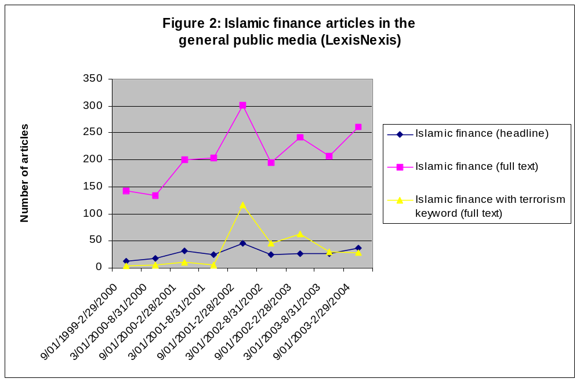

We can see from Figure 2 that in the period before 9/11, the publication of Islamic finance–related news articles was steadily increasing, while the number of articles presumably focusing on Islamic finance (with a related term in the title) was increasing at a lower rate. The number of articles mentioning Islamic finance along with terrorism was low enough to be considered insignificant. There is a significant spike in the time period that includes 9/11 and the five months immediately following the attacks; the number of articles containing possible associations of Islamic finance with terrorism increases commensurately. It can thus be said that the sudden increase in articles about Islamic finance were mainly relating it to 9/11 and terrorism in some way. In the period after 9/11, we see the number of articles potentially suggesting association between Islamic finance and terrorism decreasing quite rapidly and almost returning to the negligible pre-9/11 levels. On the other hand, the number of articles containing any Islamic finance–related terms falls in the period immediately after the 9/11 period, returning to the pre-9/11 growth rate.

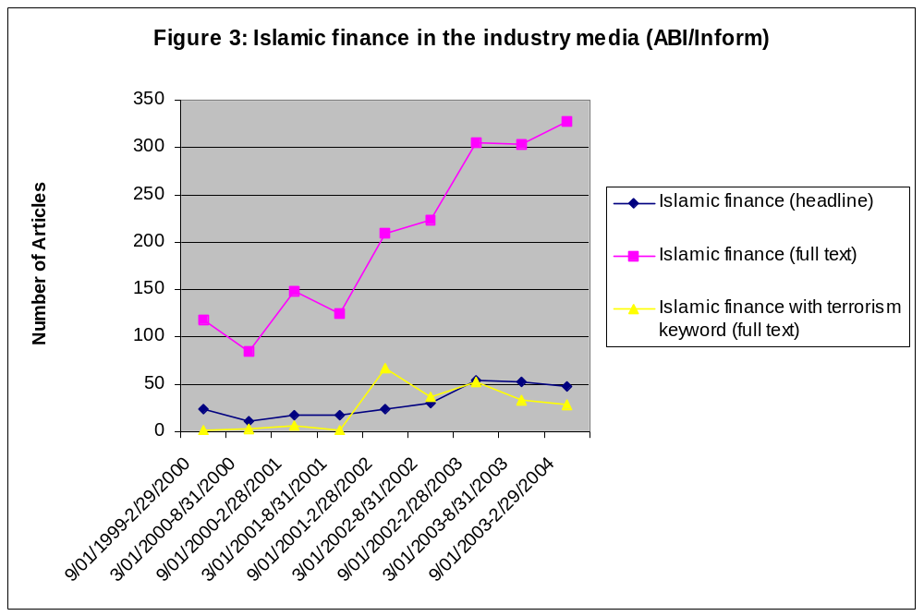

Figure 3 shows the search results from specific media. We see a spike in the total number of articles relating to Islamic finance, and a commensurate spike in articles possibly associating it with terrorism. However, unlike the general public media, this growth in coverage of Islamic finance continued after the 9/11 period, while at the same time the number of articles with keywords relating it to terrorism fell. This allows for a useful contrast with the general public media. While we saw an increase in articles potentially associating Islamic finance with terrorism, this type of coverage saw a rapid decline, while general coverage of Islamic finance continued to rise more rapidly than it rose in the broader public media. While the number of articles with an Islamic finance–related term in the title stayed relatively constant in the general public media, it rose in the specific media. This suggests an increasing number of articles focusing solely on Islamic finance.

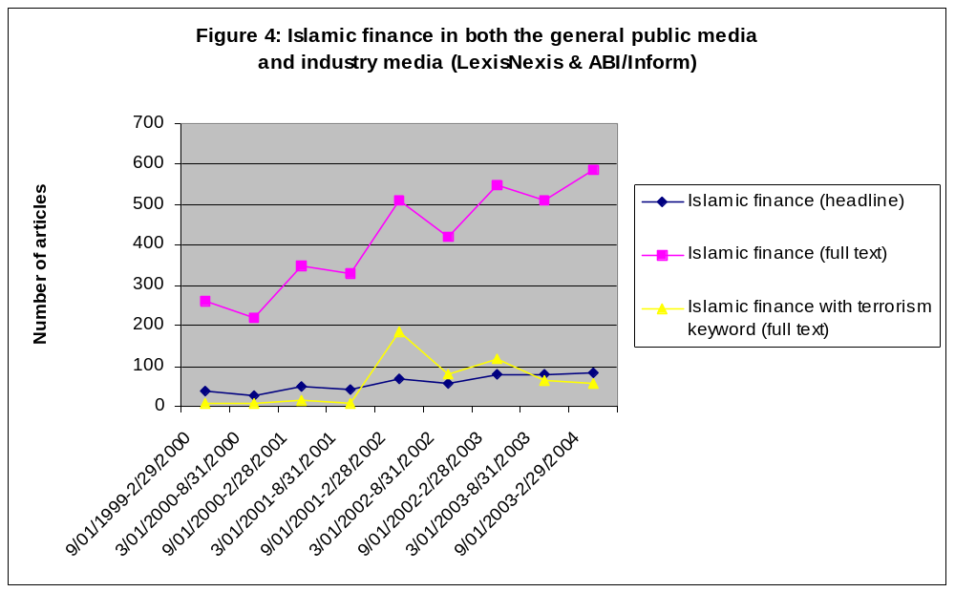

Figure 4 depicts the aggregate data of results from both LexisNexis and ABI/Inform. We can see that there is a steady increase in the number of articles with an Islamic finance–related term in the titles. More striking, however, is the fact that while 9/11 did give a slight boost in the number of articles containing some keywords related to Islamic finance, it did not cause a significant deviation from the general growth of trend of these articles. Also, while there was a sudden increase in articles potentially associating Islamic finance with terrorism, the number of such articles decreased immediately after the time period containing 9/11, almost returning to its pre-9/11 level.
A limitation of the above data analysis is that we cannot say with certainty whether the articles that contain both an Islamic finance–related term and a keyword related to terrorism actually make a connection between Islamic finance and terrorism; for this reason, it was necessary to do a close reading of selected articles published post-9/11. The thorough content analysis that we will report in the next section will allow us to come to a better conclusion about whether the articles seemingly associating Islamic finance with terrorism were actually doing so.

5. 3 Content Analysis of Selected Articles

Of the articles chosen for close reading, the majority (63 percent) avoided taking a normative stance about whether there have been positive developments in Islamic finance since 9/11. Of the 37 percent that did take a stand on the issue, the overwhelming majority (88 percent) noted that the outlook was positive for Islamic finance since 9/11. On the issue of whether Islamic finance suffered because of 9/11, the majority of the articles (76 percent) do not take a stand on the issue. However, most of the articles that did take a position (63 percent) found that the industry had suffered due to 9/11.
While the majority of the articles analyzed avoided taking a stance on whether or not there were positive developments in Islamic finance post-9/11, 67 percent of the articles did mention a link with terrorism. Of those, 43 percent of the articles suggested the existence of a link either by explicitly stating that it existed, or by presenting enough evidence or quotations to amount to asserting such a link. The remaining articles that did not directly suggest such a link mentioned the possibility that it existed. The fact that 38 percent of all the articles analyzed do mention the possibility of such a link without backing it with evidence is troubling, especially since so few of them (26 percent) give any counter-arguments to the assertion.
While this is a troubling observation, upon closer reading, it is apparent that only 13 percent of the articles maintain a negative tone toward Islam. This is a positive sign, but given prevailing Western stereotypes of Islam and Muslims in the West, a neutral article that mentions a possible link may practically amount to an association of Islamic finance with terrorism.

5. 4 Conclusions about Western media coverage of Islamic finance

Overall, as seen from the first part of our Western media analysis, articles that associate Islamic finance with terrorism form only a small—and steadily decreasing—subset of the total articles published on Islamic finance. The detailed analysis shows that within these articles, only a small percentage (13 percent) maintains a negative tone; most of the articles are either neutral or positive. While even a few negative articles can be harmful to the image of the industry, the trends we have considered show us that in general, perceptions of Islamic finance in the Western media are mostly disconnected from connotations of terrorism.

The Reaction from Islamic Finance Industry Professionals

Based on the survey we conducted (see section III), Islamic finance and banking professionals are essentially evenly split on the question of whether 9/11 had a negative impact on the Islamic finance industry. A slight majority (53 percent) disagrees with the idea that it has had a negative effect. Of those that believe it had a negative impact on the industry, 60 percent cite the economic consequences of 9/11 as a main cause, while a strong 80 percent said that political consequences were a main factor for the negative impact.
In terms of specific post-9/11 effects, responses were evenly split on whether correspondent banking was affected. Responses generally supported the notion that there were few negative effects on the industry. Specifically 71 percent of respondents noted the national and local banks were not more reluctant to enter the industry, though this was less true of Western conventional banks (59 percent). 21 percent of respondents noted that they had been privately or publicly harassed, a distressing observation though it is reassuring that the vast majority have not been harassed.
Regardless of the split overall amongst respondents about whether 9/11 has had a negative impact, the overwhelming majority (89 percent) agreed that there is 9-1of the industry post-9/11. 74 percent of the professionals surveyed indicated that this scrutiny opens opportunities for industry growth. In fact, 68 percent think that the scrutiny has led to greater awareness and understanding of Islamic finance. A notable 89 percent of respondents reject the idea that this scrutiny may lead to the industry being phased out. 79 percent of respondents do caution, however, that the scrutiny has created some misconceptions about the industry. Almost half (47 percent) also feel that the scrutiny has created some hurdles to industry growth.
The professionals surveyed were overwhelmingly supportive of proposals to improve the perception of the Islamic finance industry. All respondents supported engaging in dialogue with regulators. 95 percent agreed that consumer education should be improved. Similarly, the vast majority (79 percent) agreed with increasing financial disclosures and reports and also indicated support for a public relations media campaign. They also regarded participation by Western banks favorably (79 percent). In terms of the use of Islamic scholars, 61 percent thought that shari‘a scholars have played a role in positively influencing public perception of the industry post-9/11. In fact, 75 percent agreed that appointing an Islamic scholar to the treasury was a positive move. All of this bolsters the sense that Islamic finance professionals believe that there is indeed work to be done to improve and further the industry.
At the same time, we asked the respondents about perceived non-financial benefits that Islamic finance could bring about, in order to judge their outlook on the future of the industry. The response was overwhelmingly positive, with most of the respondents noting that among other benefits, Islamic finance will create an ethically based financial alternative accessible to non-Muslims, and would enhance socio-economic development in the Muslim world. Thus, while they perceive a number of challenges faced by the industry, their outlook is overwhelmingly positive.
In the last section of the survey, we sought to ascertain the respondents’ perceptions of the Islamic finance industry within different geographic markets (see Appendix D). In the aggregate, target customer understanding and conventional media understanding of the industry were perceived to be evenly split between good and poor (55%/45% for customers and 48%/52% for media). Regulators’ understanding of the industry was perceived to be notably higher, with 60 percent of respondents perceiving their understanding to be good. These total numbers hide some interesting regional discrepancy. While perceptions of customer understanding in North America were evenly split between good and poor, customer understanding in the United Kingdom and Europe was rated as poor by 67 percent of respondents. This contrasts strongly with the perception of 75 percent of respondents that customer understanding in both the Middle East/North Africa and Asia was good. Similarly, perceptions of conventional media understanding was evenly split between good and poor in Europe, while for North America it was perceived to be poor by 75 percent of respondents. On the other hand, 71 percent perceived that the conventional media understanding in the Middle East/North Africa region was good, while 67 percent perceived it was good in Asia. Most professionals felt that regulators’ understanding of the industry in North America and Asia is somewhat poor (75 percent and 67 percent, respectively). Conversely, 100 percent of respondents perceived that regulators’ understanding in the Middle East/North Africa and Europe markets was good.
Overall, Islamic finance professionals perceived that 9/11 brought with it certain challenges. It has brought about closer scrutiny of the industry. While this scrutiny has led to some misconceptions, it has also brought about many opportunities, including opportunities for growth, and for increased awareness and understanding of Islamic finance. Regardless of any challenges, their outlook on the future of the industry in the post-9/11 climate was very positive. Notably, all respondents indicated that in all four geographic regions, customers did not withdraw or markedly decrease their investments and deposits after 9/11.

The View from Islamic Finance Industry Media

In contrast with the perception of Islamic finance industry professionals, the media professionals writing in the field of Islamic finance generally agree (60 percent) that 9/11 has had a negative overall effect on the Islamic finance industry (see Appendix F). Also,, they perceive that the political consequences of 9/11 (100 percent) are mostly to blame for this negative effect, rather than its economic repercussions (47 percent). Despite this negative political impact, 70 percent of media professionals in the field agree that the post-9/11 scrutiny has increased opportunities for industry growth. In fact, 80 percent agree that the scrutiny has increased awareness and understanding of the industry and 89 percent reject outright the possibility of the industry being phased out. At the same time, even though opportunities for growth are present, 78 percent believe that there are still hurdles to industry development. Eighty percent of media professionals in the Islamic finance field do acknowledge that misconceptions about Islamic finance still abound. While this may seem contradictory to the perception that there has been increased awareness and understanding, it simply underscores the varying impacts that 9/11 has had on public perceptions. One respondent noted that there are likely differences in perception between different socio-economic groups and perhaps also religious groups, but we cannot ascertain this from our study.
According to regional figures, 77 percent of Islamic finance media professionals consider conventional media understanding of Islamic finance poor (see Table 8). Regulators perform much better in this regard, gaining approval from 67 percent of respondents. However, in the North American and European markets, regulators are largely seen as having a poor understanding of Islamic finance. The perception of consumer understanding in the different markets is mixed, with high levels of perceived understanding in the Middle East, Southeast Asia, and South Asia, but low levels in North America and Europe. Thus, on a regional level, it is fair to say that regulators and consumers are perceived to be less educated about Islamic finance in North America and Europe in comparison to their counterparts in the Middle East, Southeast Asia, and South Asia.
Sixty-one percent of the respondents found some level of satisfaction with local media accuracy and comprehensiveness in their coverage of Islamic finance. Media professionals in Europe had the lowest levels of satisfaction, with 60 percent of those respondents citing dissatisfaction with the local media’s accuracy. Circulation of Islamic finance media after 9/11 was reported to have gone up across the board, as reported by 67 percent of respondents. South Asia and the Middle East were the only regions in which respondents reported high levels of satisfaction over the efforts of their governments to promote understanding of Islam after 9/11. Respondents felt that the effort of governments in North America, Europe, and Southeast Asia were less than satisfactory.
In addition to being optimistic about the future growth potential for Islamic finance, media professionals in the field endorse a wide array of steps that the industry could take to improve its image. Implementing AAOIFI standards, increasing transparency, improving advertising, and crafting effective reporting mechanisms all score very highly among respondents (each rating 90 percent or greater approval). Seventy percent of respondents also consider the appointment of a special advisor to the government for Islamic finance to be a beneficial step. The proposals calling for increasing consumer education, conducting cross-industry analyses, and improving corporate communications did not garner enough responses to allow for any conclusions to be drawn.
Islamic finance media professionals perceive more of a negative overall impact of 9/11 as compared with the industry professionals. Indeed, 70 percent of the Islamic finance media professionals are critical of how the Islamic finance industry itself has handled the media attention it received after 9/11.

Conclusions

The study indicates that coverage of Islamic finance in the Western media has risen markedly. While 9/11 saw a rise in published articles associating it with terrorism, such articles were few and far between. In any case, since then there has been a constant downward trend of such articles, while coverage of Islamic finance has been concurrently increasing. These trends indicate that for the most part, Western media coverage of Islamic finance does not associate it with terrorism. The responses to our surveys indicate that both Islamic finance professionals and media professionals covering Islamic finance have noticed a greater scrutiny of the industry. Moreover, this scrutiny has created both hurdles to growth and opportunities for further understanding and awareness among consumers, media professionals, and industry regulators. Despite some media association of Islamic finance with terrorism, content analysis shows that much of the coverage seems to share the Islamic finance industry and media professionals' positive attitude toward the future growth of Islamic finance. Indeed, many of the print articles that commented on the future growth and influence of Islamic finance rated it as a positive development with high growth potential.
Regional analysis of the levels of knowledge regarding Islamic finance reveals that there is still much work to be done in terms of educating consumers, professionals, and regulators about the industry. This is certainly to be expected, given the relatively recent growth of the industry in Western markets. The combination of increased scrutiny and the general expansion of the industry create a unique opportunity for the Islamic finance industry to proactively market itself as a positive, socially-responsible banking alternative and to grow as an industry. Islamic financial professionals and media professionals both note that there are still misconceptions that need to be cleared up. The media professionals, however, warn that the Islamic finance industry has not done a very good job of representing itself in the past. This point was also stressed at a panel discussion on international media perceptions of the Islamic finance industry at WIBC 2004, in which it was indicated that the onus is on the industry itself to be more proactive in representing itself to the media.
There are positive signs that this is improving. The General Council for Islamic Banks and Financial Institutions, international nonprofit organization based in Bahrain, works to improve the industry’s relationship with the media. It sponsored the Third International Islamic Finance Conference in Washington D.C. (2002) in order to improve the industry’s image.
Progress has also been made in improving regulators’ understanding of Islamic finance. This is reflected in the appointment of an Islamic finance scholar-in-residence at the U.S. Treasury. Both the Islamic finance practitioners and media professionals surveyed in this study believed that such appointments would, aside from improving regulators’ understanding, also improve public perception of Islamic finance. This appointment is one in a series of efforts made by the U.S. Treasury to improve understanding of Islamic finance (Taylor, 2004). Most recently, the Federal Reserve Bank of New York held an interagency forum on March 16, 2006, to discuss Islamic banking in the United States.
The positive outlook of Islamic finance practitioners and media professionals is strongly reflected in the rapid growth of the industry, both in the West and in the Muslim world. In the West, two fully Islamic banks were opened in London (the Islamic Bank of Britain in 2004 and the European Islamic Investment Bank in 2005), and the number of conventional banks offering Islamic finance services (“Islamic Windows”) in the United States has been steadily increasing. In the Muslim world, a number of conventional banks are being converting into full-fledged Islamic banks, with many new Islamic banks opening. Many Western conventional banks in the region, such as Deutsche Bank, ABN AMRO, and BNP Paribas, have been opening Islamic banking windows as well. An important industry-wide development is the competition by both established and emerging financial centers for Islamic finance business: Bahrain (Bahrain Financial Harbour, established 2003); Malaysia (Kuala Lumpur and Labuan, established in 2001); Qatar (Qatar Financial Center, established in 2005), Untied Arab Emirates (Dubai International Financial Centre, established in 2002) and more recently in Singapore.
The industry as a whole has also matured significantly, with the development of institutions aimed at increasing standardization and transparency. The formation and widespread industry acceptance of the Islamic Financial Services Board, meant to serve as the international standard- setting body of regulatory and supervisory agencies for Islamic finance, is one such development (http://www.ifsb.org). The increasing implementation of standards set by the Accounting and Auditing Organization for Islamic Financial Institutions (AAOIFI) is another sign of the industry’s increasing maturity (http://www.aaoifi.com). Across the board, the Islamic finance practitioners and media professionals agree that implementation of AAOIFI standards is a necessary step forward for the industry.
In conclusion, we can safely state that following the impact of 9/11, negative coverage of Islamic finance in the media has not significantly affected the development of the industry. On the contrary, the industry appears to be rising to the challenge of improving media relations. As evidenced by the views of Islamic finance practitioners and media professionals, increasing coverage in Western media, and the sustained growth of the industry worldwide, the outlook for future development of the industry is overwhelmingly positive.

References

- ABC/Beliefnet polls were conducted by telephone with respondents throughout the United States by TNS Intersearch on 9 October 2001, 6 January 2002, 15 October 2002, and 7 September 2003, with a 3 percent margin of error. 2002 poll: http://abcnews.go.com/sections/us/DailyNews/poll_Islam020124.html.
- ABC News/Washington Post Poll, 2006. Views of Islam. http://abcnews.go.com/images/International/Islam_views.pdf. The poll was conducted by telephone March 2–5, 2006, among a random national sample of 1,000 adults. The results have a three-point margin of error. Sampling, data collection and tabulation was done by TNS of Horsham, Pennsylvania.
- Ahmad, Norafifah and Haron, Sudin, 2002. “Perceptions of Malaysian corporate customers towards Islamic banking products and services,” International Journal of Islamic Financial Services 3, pp.1-16.
- Ali, S. Nazim, 2008. Islamic Finance and Economics as Reflected in Research and Publications”, Review of Islamic Economics, 12, pp.151-168.
- CAIR, 2004. A significantly smaller number of complaints (80) were filed in 1995–96, which might be attributed to it being the first year in which CAIR registered complaints. The reporting year appears to be March to March. Institute of Social Policy and Understanding, “The USA Patriot Act: Impact on the Arab and Muslim American Community” (Clinton Township, Michigan: Institute of Social Policy and Understanding, 2004).
- Gerrard, P. and Cunningham, J.B. 1997. “Islamic banking: a study in Singapore,” International Journal of Bank Marketing 15, pp.204-216.
- The Great Divide: How Westerners and Muslims View Each Other, June 22, 2006.” Pew Global Attitudes Project Survey. http://pewglobal.org/reports/display.php?ReportID=253.
- Haron, S.; Ahmad, N. and S. Palnisek, 1994. “Bank patronage factors of Muslim and non-Muslim customers,” International Journal of Bank Marketing 12, pp.32-40.
- “Islamic banks stung by claims they fund violent extremists terrorists' finance,” Financial Times (London) October 8, 2001, USA edition, pp. 6.
- Koprowski, Gene J. 2001. “Islamic Banking is Not the Enemy,” The Wall Street Journal Europe (1 October 2001), cited in Ibrahim Warde, “Global Politics, Islamic Finance and Islamist Politics Before and After 11 September 2001,” The Politics of Islamic Finance, ed. Henry, Clement and Wilson, Rodney, Edinburgh: Edinburgh University, 2004.
- Mennai, Khalid, 2004. “International Media Perceptions of Islamic Finance Industry,” World Islamic Banking Conference, Manama, Bahrain, December 11–13.
- Metawa, S.A. and Almossawi, M., 1998. “Banking behaviour of Islamic banking customers: perspectives and implications,” International Journal of Bank Marketing 16, pp.299-313.
- Nisbet, Erick and Shanahan, James, 2004. “Special Report: Restrictions on Civil Liberties, Views of Islam, and Muslim Americans” (Ithaca, New York: Media and Society Research Group, Department of Communication at Cornell University, December)
- Raja, Fatima, 2002. “Islamic Finance in the Contemporary Context,” Proceedings of the Fifth Harvard University Forum on Islamic Finance. Cambridge, Massachusetts, April 6–7, 2002, pp. 277-280.
- Rahman, Mehbubur, 2005. “Breeding of Islamophobia,” The Message International 31, 8-9.
- Taylor, John B, 2004. Keynote Speech at the Sixth Harvard University Forum on Islamic Finance. (http://www.ustreas.gov/press/releases/js1543.htm).
- YouGov, 2002. Attitudes toward British Muslims: a survey commissioned by the Islamic Society of Britain and conducted by YouGov” http://www.isb.org.uk/iaw/docs/SurveyIAW2002.pdf. A representative sample of 1,890 electors throughout Britain was polled online on 31 October and 1 November, 2002.
- Views of Islam Remain Sharply Divided: Plurality Sees Islam as More Likely to Encourage Violence,” 2004 Survey by the Pew Forum on Religion and Public Life, http://people-press.org/commentary/display.php3?AnalysisID=96.
- The WIBC, 2005 [World Islamic Banking Conference, Manama, Bahrain] tackles thorny issues about Western perception of Islamic banking (www.ameinfo.com),

